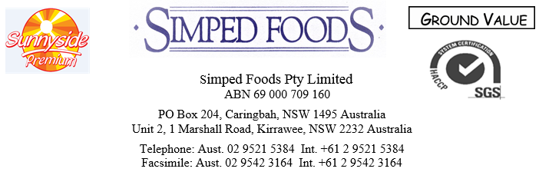
Doc No. 1
Page: 1/3
Revision: 12.5.20
Date: 18.6.19
OKRA
PRODUCT DESCRIPTION:
Frozen IQF Okra is prepared from clean and sound succulent and edible fresh pods of the okra plant (Hibiscus Esculentus) of the green variety. Blanched to negative peroxidase, the product consists of trimmed whole pods, which may possess an edible portion of the cap.The process shall ensure stability of colour and flavour.

PRODUCT LISTING:
Okra
CHEMICAL SPECIFICATIONS:
Comply with the Australian Food Standards and New Zealand Food Standards Code.

NUTRITIONAL INFORMATION
SERVE PER PACKAGE:10
SERVE SIZE:100g
 | PER SERVE | PER 100g
ENERGY | 114kJ | 114kJ
PROTEIN | 3.1g | 3.1g
FAT | 0.2g | 0.2g
SATURATED FAT | 0.0g | 0.0g
CARBOHYDRATE TOTAL | 1.4g | 1.4g
SUGARS | 1.4g | 1.4g
SODIUM | 2mg | 2mg
MICROBIOLOGICAL SPECIFICATIONS:
Microbiological quality:
- Aerobic plate count not above 100.000/g
- Coli forms not above 500/g
- Streptococcus not above 100/g
- Yeasts not above 500/g
- Moulds not above 100/g
- Listeria absent in 25gm
ORGANOLEPTIC QUALITY:
Length : up to 2.5 cm
Diameter 1.5cm max
Flavour & Odour: Good distinctive flavour and Odour, characteristic of young tender Okra
Colour: The colour should be bright green
typical of the variety.
Texture: Fleshy and tender with seeds in
early stages of maturity
Insects : Negative
2/3
Preservatives : Free
ALLOWANCE FOR DEFECTS
(MAX PER 50 PODS)
Foreign Matter: Free
Blemish units: 3 units
Poorly trimmed: 10 units
Mechanical damage: 5
Tough fiber: nil
Extraneous vegetable matter: 1

Pesticide Residues:
Pesticides are used only according to regulations of Egypt, the residues of these pesticides are no more than allowed in codex alimentarius.

BLANCHING:
Negative Peroxide.
PACKAGING:
In 10 kg polyethylene bags and or
12 x 1kgzip lock foil bags in labeled new cartons.

LABELLING REQUIREMENTS:
Best before/contents & wt/company name & address.

STORAGE REQUIREMENTS:
Freezer: < ˉ18˚C.

SHELF LIFE:
Freezer: 18months.

COUNTRY OF ORIGIN:
Egypt.

GENETICALLY MODIFIED ORGANISM DECLARATION:
This product does not contain genetically modified material.

APPLICATION/USAGE:
As a stand alone product or as an ingredient in other food products.

ALLERGEN DECLARATION:
This product does not contain any mandatory allergens which need to be declared.

P3/3

ALLERGENS | Name of  Allergen | Specify % of derivative in product | Specify % in allergen derivative | DIRECT INGREDIENT |  | CROSS CONTAMINATION
 |  |  |  | Yes | No | Yes | No
Cereals containing gluten (i.e.wheat, rye, barley,  oats, spelt) |  |  |  |  |  |  | 
Crustaceans and products |  |  |  |  |  |  | 
Eggs and egg products |  |  |  |  |  |  | 
Fish and products |  |  |  |  |  |  | 
Peanuts and products |  |  |  |  |  |  | 
Soybeans and products |  |  |  |  |  |  | 
Milk and products |  |  |  |  |  |  | 
Nuts and products |  |  |  |  |  |  | 
Seasame seeds and products |  |  |  |  |  |  | 
Sulfur dioxide and sulphites at concentrations |  |  |  |  |  |  | 
Lupin & Lupin products |  |  |  |  |  |  | 
Honey and Royal Jelly and products |  |  |  |  |  |  | 

