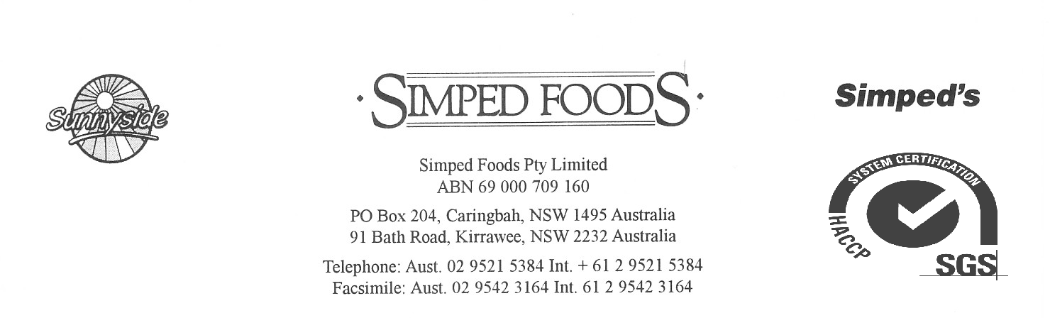

Doc No. 1
Page: 1/3
Revision: 8.2.18
Date: 2.4.14
DICED ONION IQF
PRODUCT DESCRIPTION:
The raw material is freshly harvested in a manner to ensure an absence of foreign matter, whilst keeping it firm and undamaged.The onions selected for processing must be clean, fresh, sound and free from disease and infestation. The onions are washed, inspected, diced and de watering , before freezing. The onions are sorted and selected then packed into food grade, machine stitched sacks or in coloured polythene lined export grade cartons, and then warehoused in a hygienic manner. The final packed off is reselected and screened by metal detector. The product is free flowing and store at ¯18°C.
PRODUCT LISTING:
IQF Diced Onion.

CHEMICAL SPECIFICATIONS:
Comply with the Australian Food Standards and New Zealand Food Standards Code.

NUTRITIONAL INFORMATION
SERVE PER PACKAGE:40
SERVE SIZE:50g
 | PER SERVE | PER 100g
ENERGY | 74kJ | 148kJ
PROTEIN | 0.8g | 1.6g
FAT | 0.0g | 0.1g
SATURATED FAT | 0.0g | 0.0g
CARBOHYDRATE TOTAL | 3.1g | 6.2g
SUGARS | 2.2g | 4.4g
SODIUM | 6.5mg | 13mg
MICROBIOLOGICAL SPECIFICATIONS:
Total viable count: <100,000/g
Yeasts & Moulds: <100,000/g
Coliforms: <500/g
E.Coli: <10/g
Listeria: absent in 25g.
Salmonella: absent in 25g.

P2/3

PHYSICAL CHARACTERISTICS:
Colour: Bright colour, typical of the vegetable.
Flavour: Characteristic of the variety, no off flavours.
Texture: Firm and not overly soft after cooking.
E.V.M: Absent
Welding/clumping: 6%
Roots: Absent
Foreign Matter: Absent

GENETICALLY MODIFIED ORGANISM DECLARATION:
This product does not contain genetically modified material.

PACKAGING:
6 x 2kg food grade polyethelene bags in labeled new cartons.

LABELLING REQUIREMENTS:
Identification of production factory, best before/contents & wt/company name & address.

STORAGE REQUIREMENTS:
Freezer: below ˉ18ºC.

SHELF LIFE:
Freezer: 24 months.

COUNTRY OF ORIGIN:
China.

APPLICATION/USAGE:
As a stand alone product or as an ingredient in other food products.

P3/3

ALLERGEN DECLARATION:
This product does not contain any mandatory allergens which need to be declared.

ALLERGENS | Name of  Allergen | Specify % of derivative in product | Specify % in allergen derivative | DIRECT INGREDIENT |  | CROSS CONTAMINATION
 |  |  |  | Yes | No | Yes | No
Cereals containing gluten (i.e.wheat, rye, barley,  oats, spelt) |  |  |  |  |  |  | 
Crustaceans and products |  |  |  |  |  |  | 
Eggs and egg products |  |  |  |  |  |  | 
Fish and products |  |  |  |  |  |  | 
Peanuts and products |  |  |  |  |  |  | 
Soybeans and products |  |  |  |  |  |  | 
Milk and products |  |  |  |  |  |  | 
Nuts and products |  |  |  |  |  |  | 
Seasame seeds and products |  |  |  |  |  |  | 
Sulfur dioxide and sulphites at concentrations |  |  |  |  |  |  | 
Lupin & Lupin products |  |  |  |  |  |  | 
Honey and Royal Jelly and products |  |  |  |  |  |  | 

