## Seven Seas Seafoods (Aust) Pty. Ltd.

A.C.N.: 057 896 947 A.B.N.: 36 537 360 721

**24 Hughes Street, Yarraville VIC 3013**

**PO BOX 581 South Melbourne VIC 3205**

**Phone 03 9362-0260 Fax 03 9362-0556**

## Product Specification

**Raw Lobster Tails**

Brand: Capricorn

Country of Origin: Brazil

Grades: 10 - 12oz (283 – 340g)

Stock Code: MI009119

Primary Packaging: 4.54kg Cardboard Carton.

No. of Units : Per Layer: 9 ctns Per Pallet: 72 ctns

Storage Requirements: Store at or Below –18° C

Ingredients: Lobster, Water, Sodium Metabisulfite E-223

Allergens: Contains Lobster

Nutritional Information: Serving Size: 110g

|  |  |  |
| --- | --- | --- |
|  | Average Quantity Per Serving | Average Quantity per 110g |
| Energy (kj)  Protein (g)  Fat – Total (g)  – Saturated (g)  Carbohydrate (g)  – Sugars (g)  Sodium (mg) | 502  23.0  1.7g  0  3.0  0  190 | 502  23.0  1.7g  0  3.0  0  190 |

Shelf Life: Up to 2 years from date of manufacture but

variable depending on storage conditions.

Best Before date detailed on packaging.

Label Information: Complies with all specifications as

detailed in the Australian Foods Standards Code.

Type of Transport: Clean, dry, refrigerated Truck.

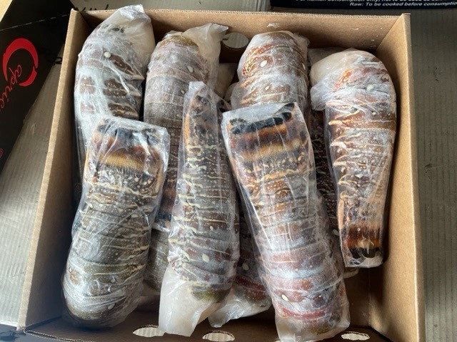

The product is purchased, imported and sold as being compliant with the Australian Food Standards Code.